# *International Society of Air Safety Investigators*

*Submission for the 2017 ISASI Seminar in San Diego, California*

**Why it Makes a Difference to Report and Investigate UAS Incidents … Even When They Don’t Really Happen**

## By Jeff Guzzetti, AO3317

[Jeffrey.guzzetti@faa.gov](mailto:Jeffrey.guzzetti@faa.gov)

**________________________________________________________________________________**

*Jeff Guzzetti is the Director of the Accident Investigation Division( AVP-100) at the U.S. Federal Aviation Administration (FAA), a position he has held since May 2014. He also served as the Assistant Inspector General for Aviation Audits at the U.S. Department of Transportation's Office of the Inspector General for four years, where he led audits of FAA aviation safety programs. Mr. Guzzetti’s prior experience also includes 18 years with the U.S. National Transportation Safety Board's (NTSB) Office of Aviation Safety, where he served as a field investigator, major accident investigator, and the Deputy Director of Regional Operations. He has also worked as an air safety investigator with the Cessna Aircraft Company, and as a safety engineer with the U.S. Naval Air Systems Command.  Mr. Guzzetti earned a B.S. degree in Aeronautical Engineering from Embry-Riddle University and holds a Commercial Pilot license with multiengine, instrument ratings, and is also rated in seaplanes and gliders.*

**The views expressed in this paper do not necessarily represent the views of the United States (U.S), the U.S. Department of Transportation (DOT), the Federal Aviation Administration (FAA), or any other Federal agency.**

_____________________________________________

**Abstract**

Now that the FAA has issued its Part 107 Final Rule on “small” commercial Unmanned Aircraft Systems (UAS) operations, along with its requirements for a remote pilot certificate and electronic accident reporting, the agency is now working to issue a rule that addresses UAS operations “over people” (so called) that will define UAS categories by the level of injury risk posed. Over 60,000 small UAS commercial operators have been approved in the United States (U.S.) alone, with nearly 800,000 UAS hobbyists registered. The time is now for the world’s largest aviation system to address the fears – both real and imagined – of a fatal collision between a UAS and a manned aircraft. Proper protocols for reporting and investigating UAS accidents and incidents is a core need for this endeavor. This paper presents a concise summary of the FAA’s new rules with specific emphasis on their impact to air safety investigators. Actual cases of recent UAS accidents or near-accidents, conducted by the FAA, the U.S. National Transportation Safety Board (NTSB) and international aviation authorities are discussed along with the many challenges posited by this aviation evolution. These challenges include filtering through the hundreds of distracting near-miss sightings, investigating the many “false positives” of collision events that were later disproven as a bird strike or other event, clarifying the confusion of the disparate reporting requirements between the FAA and NTSB, and educating the public and UAS community about UAS events. This paper purports that the reporting and investigating of UAS accidents and incidents – even when they didn’t really happen – will most certainly “make a difference” in preventing the next (or the first) catastrophic UAS encounter by informing the public, the aviation industry, and safety researchers about actual UAS collision risks.

**Introduction**

The emergence of small unmanned aircraft systems (UAS)—a technology commonly referred to as “drones”—has great potential to the economy and the society of not only the United States (U.S), but the world at large. Small UAS -- those weighing less than 55 pounds in the U.S. -- are used for a variety of recreational and commercial purposes, including taking aerial photographs, monitoring crops, and inspecting infrastructure. These aircraft are typically flown by remote control within *visual line of sight* (VLOS) of an operator who is located on the ground. However, businesses and others are interested in expanding commercial small UAS operations to allow aircraft to operate *beyond* VLOS for such uses as delivering packages, conducting remote inspections, and gathering video for news reporting.

Analysts predict that as much as $93 billion will be invested worldwide over the next 10 years in commercial UAS technology. ***(1)*** Over 60,000 small UAS commercial operators have already been approved in the U.S., and sales are expected to reach almost 3 million units in 2020 in the U.S. alone. ***(2)*** Additionally, nearly 800,000 UAS hobbyists have registered their small UAS with FAA, more than double the 320,000 manned aircraft registered with the agency. ***(3)*** And to top it all off, it is projected that the number of larger UAS – those weighing 55 pounds or more, is expected to surpass the number of active General Aviation (GA) aircraft in 15 years, as shown in Figure 1 below. ***(4)*** Integrating all of these aircraft into the National Airspace System (NAS) and assessing the safety impacts of such sudden growth is a significant challenge.

**Figure 1:**

**Projections of the Numbers of GA Aircraft versus Large UAS**



**Active GA Aircraft**

**Comm.& Public UAS >55 lbs.**

As UAS operations become integrated into the NAS, the aviation industry and the public have become obsessed with the potential that, one day, a collision could occur between a UAS and a human-piloted aircraft. This persisting obsession exists despite the fact that there have been no confirmed collisions between a “modern drone” and a civil manned aircraft to date, not only in the U.S., but abroad.

Risks associated with UAS are often related to reports of encounters with manned aircraft sightings near airports.  While various programs have been established to collect this information, the sharing of data and collaboration on safety analysis are still in early stages of maturity.  The investigation of UAS sightings and, when warranted, root cause analysis of incidents in which a UAS and a human-piloted aircraft are verified to have come in close proximity, are essential to validate the effectiveness of the safety controls in place today for preventing accidents in this emerging segment of transportation. More importantly, such analyses would also help guide the industry’s ongoing research into the development of future safety controls related to the operation and design of UAS.

**New Rules of the UAS Road**

A discussion of the regulatory framework for UAS operations and its affiliated support structure provides a useful backdrop to discuss the value of investigating UAS accidents and incidents. This paper presents what is happening mostly in the U.S. -- the busiest aviation system in the world -- with the FAA, NTSB, and industry. However, parallels can certainly be drawn for other countries.

Registration of UAS

In December 2015, the FAA issued an *Interim Final Rule on Registration and Marking Requirements for Small Unmanned Aircraft*, which applied to all UAS – including those used by “modelers” and “hobbyists” -- weighing over 0.55 lbs. (250 grams) and under 55 pounds. *(5)* The FAA required the use of a web-based registration process, and then used that process to educate users about how to safely operate UAS in the NAS. Prior to completing the process, registrants read and acknowledged safety guidelines, which included instructions on the prohibitions of flight near manned aircraft and within visual line-of-sight of the operator.

The FAA’s primary approach to new UAS operators is education and outreach; however, the agency also has authority to take enforcement action against any persons who operate a UAS in an unsafe manner. The FAA’s registration rule facilitated all of these aspects. However, this past May, the rule was struck down by the U.S. Court of Appeals because it conflicted with a law that was passed by the U.S. Congress which states that the FAA “may not promulgate any rule or regulation regarding a model aircraft.” ***(6)*** While the FAA reviews this decision and considers other action, nearly 800,000 registrations in the 17 months that the rule were completed.

Commercial UAS Rules

One year ago this month, another new FAA rule became effective in the U.S. for small UAS operations intended *for commercial purposes*. This rule – known as “Part 107” -- offers safety regulations for UAS weighing less than 55 pounds that are conducting “non-hobbyist” operations for commercial purposes. ***(7)*** The new rules have opened up a wide array of commercial operations that previously required a case-by-case exemption or waiver. Part 107 is already opening pathways towards the full integration of UAS into U.S. airspace. According to industry estimates, the rule could generate more than $82 billion for the U.S. economy and create more than 100,000 new jobs over the next 10 years. ***(8)***

The FAA is not yet requiring small UAS to comply with current agency airworthiness standards for manned aircraft certification; however, under the new Part 107 rules, operators must do the following ***(9)***:

* Obtain a remote pilot certificate by passing an aeronautical knowledge exam.
* Be at least 16 years old, or be supervised by someone at least 16 years old.
* Be responsible for ensuring a drone is safe before flying - by performing a preflight visual and operational check of the UAS
* Fly under 400 feet above the ground, in uncontrolled (Class G) airspace
* Fly within Visual Line of Sight (VLOS)
* Fly during the day (or during twilight hours if anti-collision lights)
* Fly at or below 100 miles per hour
* Yield right of way to manned aircraft
* Not fly over people
* Not fly from a moving vehicle unless in a rural area

Accident Reporting of UAS to the FAA

The Part 107 rule also introduced a requirement that is the first of its kind for the FAA – to report a UAS accident directly to the FAA. Specifically, Part 107.9 states: ***(10)***

*No later than 10 days after an operation that meets the criteria of either paragraph (a) or (b) of this section, a remote pilot in command must report to the nearest Federal Aviation Administration Flight Standards District Office, in a manner acceptable to the Administrator, any operation of the small unmanned aircraft involving at least:*

*(a) Serious injury to any person or any loss of consciousness; or*

*(b) Damage to any property, other than the small unmanned aircraft, unless one of the following conditions is satisfied:*

*(1) The cost of repair (including materials and labor) does not exceed $500; or*

*(2) The fair market value of the property does not exceed $500 in the event of total loss.*

This new requirement prompted an urgent need for the FAA to quickly develop an accident reporting vehicle for commercial UAS operators to utilize if they experienced an “accident” – as per FAA’s new definition cited above. To pass federal rulemaking muster, the reporting mechanism also needed to be simple, non-burdensome, and not duplicative of other aircraft accident reporting mandates. The author participated in this effort, and promoted the concept that other inspectors had previously implemented for an on-line reporting form for laser strikes by pilots. Figure 2 provides a screen shot presentation of the FAA’s current UAS accident reporting form. ***(11)***

**Figure 2:**

**FAA On-line Accident Reporting Form**

 

As of June 2017, 33 entries were submitted in this FAA system. However, the majority of the events reported were not “accidents” as per the FAA’s definition. Only 6 of the reports were actual UAS “accidents” (as per the FAA definition) and all involved the “$500 property damage” criteria. None of the reports involved a midair collision. ***(12)***

NTSB’s Definition and Requirements for UAS Accidents

In August 2010, the NTSB issued a Final Rule ***(13)*** that codified when NTSB is required by Congress to investigate an accident involving a UAS. The NTSB’s definition for a UAS accident is:

*“… an occurrence associated with the operation of any public or civil unmanned aircraft system that takes place between the time that the system is activated with the purpose of flight and the time that the system is deactivated at the conclusion of its mission, in which:*

*(1) Any person suffers death or serious injury; or*

*(2) The aircraft has a maximum gross takeoff weight of 300 pounds or greater and sustains substantial damage.*

The rule stipulates that if a civil UAS weighs *at least 300 pounds*, and is *“substantially damaged”* -- under the same NTSB damage criteria for manned aircraft-- then the NTSB *must* investigate. The rule also cites that the NTSB must investigate any UAS -- no matter the weight -- if a *“serious injury”* or fatality results -- under the same NTSB injury criteria for manned aircraft. In other words, a small 2-pound UAS that causes a serious injury is an accident. As per the NTSB Final Rule, an operator of a UAS must notify the NTSB immediately if the UAS is involved in an accident. The rule does not stipulate that the FAA must be notified.

Additionally, the operator of a UAS must immediately notify the NTSB for any of the “reportable incident” criteria that its rules have for *manned* aircraft. This includes flight control malfunctions, in-flight fires, ect. The NTSB is not mandated to investigate these NTSB incident reports, but they have the authority to investigate if they so choose. Figure 3 below provides a side-by-side comparison between the FAA and NTSB reporting requirements for UAS accidents.

**Figure 3:**

**Part 107 versus NTSB Rules Regarding UAS Accidents**

|  |  |  |
| --- | --- | --- |
|  | **FAA Part 107** | **NTSB** |
| **Serious Injury** | Level 3, 4, 5 on the AIS Scale – reversible injury but requires hospitalization. | Part 831 – broken bones;  48-hr hospitalization. |
| **Damage Threshold** | Repair or fair market value exceeds $500 | Part 831 definition of “substantial damage” |
| **Time to Report** | No later than 10 days | Immediately |
| **Reportable Incidents** | Not Applicable | As per Part 831 listing |
| **Reporting Mechanism** | FAA web site form | Not defined - Can be verbal |
| **Intended Use** | Safety *and* Enforcement | Safety only |
| **Hobbyist Events** | Only if operated illegally | Not Applicable (as an accident) |
| **Final Report** | FAA 8020-23 Form *(same for any manned aircraft)* | NTSB Format - *Same as for manned aircraft accident* |
| **Investigation Protocols** | Same for Manned Aircraft | Same for Manned Aircraft |

As one can surmise, the situation of having two separate federal agencies with two different UAS accident reporting requirements can breed confusion and duplication. Aside from the differing damage criteria between the two requirements *(NTSB has “substantial damage” versus the FAA’s financial damage)*, a different definition also exists for “serious injury” between the NTSB’s CFR 830.2 verbiage *(i.e. broken bones, 48-hour hospitalization)* that been used for decades, and the “Abbreviated Injury Scale” or “AIS”, which is an anatomical-based coding system created by the Association for the Advancement of Automotive Medicine to classify and describe the severity of injuries. Additionally, the NTSB requires that a UAS operator reports the accident “immediately” while the FAA allows 10 days. Finally, the FAA’s accident reporting form may be used for enforcement action, while the NTSB reports cannot. In anticipation of potential confusion, key people in both the NTSB and FAA (including the author) have agreed to share information immediately with each other when reports come in to either agency. Additionally, these same people meet every six months to discuss each event and determine if improvements or clarifications are needed.

Since the issuance of this NTSB UAS rule in 2010, there have only been five UAS accidents – as per NTSB’s definition**. *(14)*** All five met the “substantial damage” criteria for UAS that weighed over 300 pounds. None involved injuries. A synopsis of these five cases is presented in Figure 4 below.

Figure 4:

**NTSB Accident Investigation Cases Since 2010**

* **NTSB Case no. DCA15CA117 –May 1, 2015 - Titan Solara 50** solar-powered experimental UAS crashed shortly after takeoff near Otto, New Mexico. *Probable cause:* *Structural failure of the left wing due to an overspeed condition.*
* **NTSB Case no. DCA14CA043 -- January 27, 2014 - MQ-9 Predator** operated by the U.S. Customs and Border Protection was substantially damaged following an intentional ditching 23 miles west of Point Loma, California. *Probable cause*: *intentional controlled ditching of the aircraft due to failure of the starter/generator supplying electrical power to the aircraft.*
* **NTSB Case no. ANC13TA072 - July 26, 2013 - SIERRA UAS** operated by NASA as a public use flight for research, was believed to have sustained substantial damage after impacting ocean ice approximately 90 miles north of Prudhoe Bay, Alaska. *Probable cause: continued operation into engine intake system icing conditions resulting in a loss of power; due to schedule pressure and an insufficient risk management process.*
* **NTSB Case no. DCA13CA088 -- May 10, 2013 - MQ-9 Predator**, operated by the US Customs & Border Protection, experienced a bounced landing and runway excursion at the Patrick Air Force Base, Florida. The aircraft was substantially damaged. *Probable cause*: *An improper flare leading to a nose-wheel first touchdown, which resulted in a pilot induced oscillation (PIO). The PIO caused the UAS to pitch up abruptly on the third nose gear contact, resulting in the separation of the nose wheel assembly from its strut.*
* **NTSB Case no. DCA12CA023 - December. 20, 2011 - Experimental Meridian UAS**, operated by the University of Kansas, crashed on final approach at McMurdo Station, Antarctica and was substantially damaged. *Probable cause:* *An aerodynamic stall induced by an inadvertent autopilot Home command. The Home command was entered following a loss of the direct radio link due to improperly set failsafe settings, and an unintentional latching of Home mode from an earlier test.*

**UAS Investigation Processes**

In his excellent paper entitled “*Unmanned Aircraft System Accidents: Learning to Predict the Unpredictable”* ***(15)***, which was presented at the 2013 ISASI Annual Seminar in Vancouver, Tom Farrier asks important questions for air safety investigators::

*To what extent is it desirable or practical to investigate accidents and incidents of UAS of different sizes?*

• *What types of UAS accidents and incidents warrant in-depth investigation?*

*• Does it make sense to expend investigative resources on small UAS accidents? If so, under what circumstances?*

The paper asserts that “to avoid being completely overwhelmed by events, investigators should concentrate on those involving see-and-avoid breakdowns, control (uplink) and data (downlink) failures, and GPS-related malfunctions, along with the failure of any system intended to provide an alternate means of compliance with existing see-and-avoid rules.”

With this excellent advice in mind, and given the mandate of the NTSB for UAS accidents, the agency has elected to handle the five aforementioned accident investigation as lower-level cases which did not warrant even the launching of an NTSB investigator. This is because that the accidents did not involve a potential for a midair collision and were the result of only UAS damage criteria during a test flight or remote operation. This is prudent, given the limited resources of aviation accident investigation entities. While NTSB must investigate every UAS accident, it does so with the ability to scope up or down each investigation. Figure 5 below provides a basic flow chart of the NTSB’s decision to investigate, given the circumstances from the notification and its own definitions. ***(16)***

**Figure 5:**

**NTSB Accident Investigation Decision Logic**

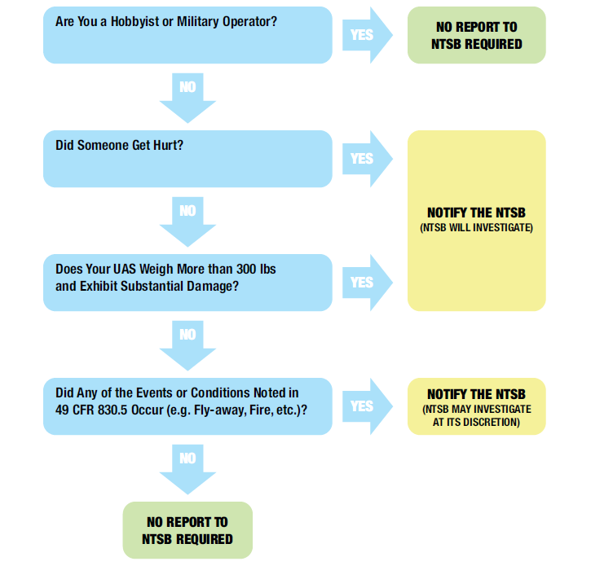

We have already stated there have been no verified collisions between a human-piloted aircraft and a UAS. It is therefore apparent that when those very first events occur in the U.S. – whether the collision results in serious/fatal injuries or not -- both the NTSB and the FAA will launch on the accident with maximum effort. Following those events, and assuming future losses are not catastrophic, the response may be less. Regardless, as Mr. Farrier states: “investigators should concentrate on those involving see-and-avoid breakdowns.” For now, the NTSB’s process for investigating a UAS accident is the same as its process for manned aircraft accidents.

The FAA also investigates UAS accidents, either as a full and automatic “participant” in an NTSB investigation, or own its own if the NTSB is not involved. As previously stated, the FAA has its own definition of a UAS accident, and must act accordingly when notified of one. Like the NTSB, the FAA’s process, for now, is also generally the same for manned aircraft accidents. FAA follows the general guidance in FAA Order 8020.11C, *Aircraft Accident and Incident Investigation, Reporting, and Notification.* ***(17)*** For any UAS accident that involves serious injuries, fatalities, midair collision with a manned aircraft, or any high-visibility aspect, the FAA’s elite investigators from its Accident Investigation Division (AVP-100) in Washington, D.C. will provide the FAA investigator-in-charge (IIC) / coordinator. For all other UAS accidents and incidents, AVP-100 will coordinate with the FAA’s UAS Integration Office, or with its Flight Standards Service to determine which office will assume FAA IIC responsibility. These offices must all work well together in a collaborate fashion, and also with NTSB, to ensure an effective investigation. Accident investigation is a team sport, no matter what type of aircraft.

**The Importance of Investigating UAS Incidents**

While UAS collision accidents have yet to occur, the need for air safety investigators to investigate incidents remains an important task for many reasons such as: to inform the evolving strategy of implementing UAS into the NAS; to validate on-going safety research; to identify hazards; to improve investigation techniques; and to allay -- or incite -- public concern as appropriate.

Feeding the UAS Evolution Strategy

To ensure the future success of collision avoidance and mitigation solutions, the hazards that may be encountered and the scope of the resulting risks of introducing UAS into the NAS must be well understood. Given the rapid pace of UAS technology development its deployment on virtually limitless missions, the potential for new hazards to human-piloted aircraft in the NAS is also evolving at a rapid pace. This is why the FAA has established an implementation strategy that starts with simpler, more conservative goals and moves towards more complex and riskier operations involving much larger UAS. Figure 6 below provides a graphical representation of this strategy. ***(18)***

**Figure 6:**

**FAA Rulemaking Strategy for the Evolution of UAS**

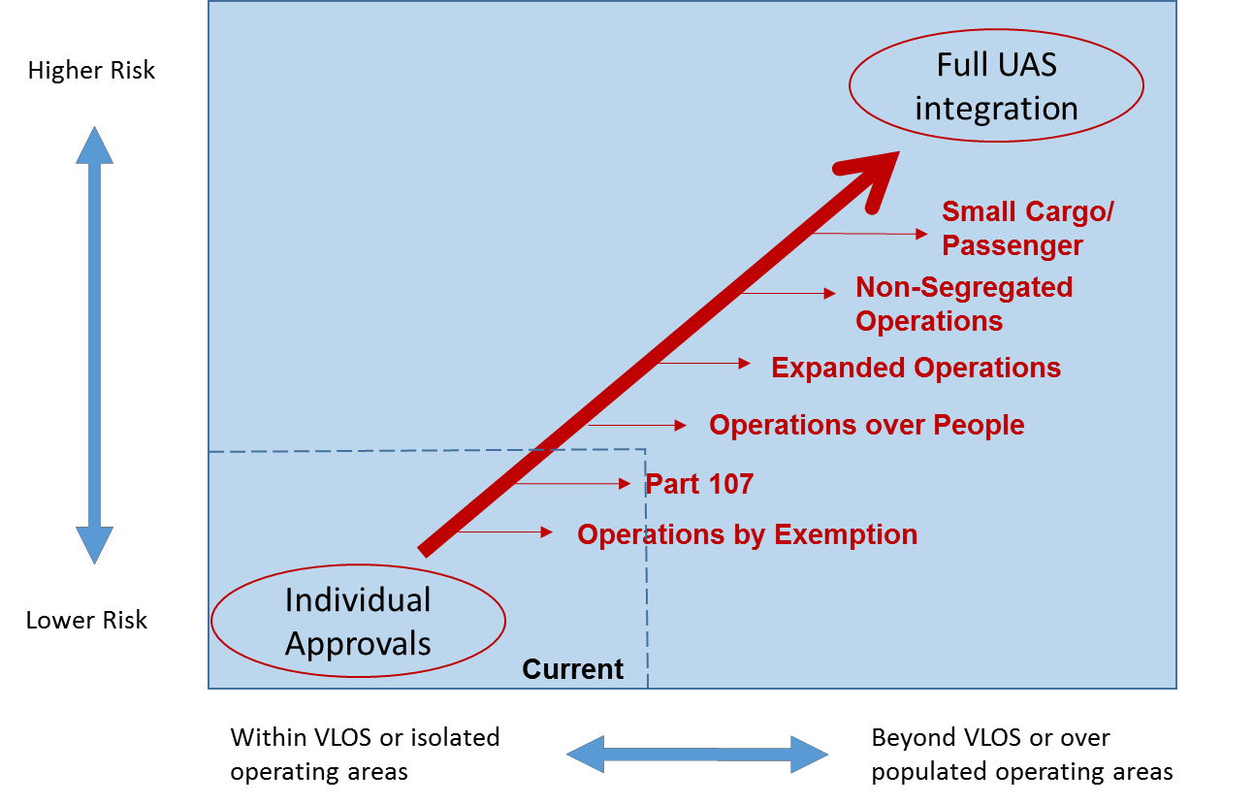

There are a number of safety challenges in the integration of UAS into the NAS, such as: the inability of UAS to comply with visual rules and clearances; UAS communication and control link reliability; and UAS interactions with the Air Traffic Management (ATM) system and airport environment and infrastructure. UAS reliance on instruments rather on pilot’s vision is one the greatest challenges of UAS integration in the NAS, as current VFR rules requires the use of pilot’s eyes to comply with any clearance that includes visual components to see the airport, runway, or see-and-avoid other aircraft, obstructions or weather. Also, current ATM automation systems do not account for the unique profiles, flight dynamics, and distributed architecture of UAS. ***(19)***

The Usefulness of Airborne UAS Sighting Reports

From February 2014 to December 2016, FAA collected about 3,200 reports of UAS sightings in potentially unsafe proximity to manned aircraft. The number of reported sightings increased nearly five-fold from 237 in 2014 to 1,211 in 2015, and then increased by another 50 percent in 2016 to 1,839, as shown in Figure 7 below. *(20)* It is reasonable to assume that the risk of potentially unsafe operations would be expected to increase as more UAS enter the NAS. The majority of those reports -- 85 percent -- are from pilots, with smaller numbers from the general public, law enforcement, air traffic controllers, and others. The reports almost always involve sightings of UAS operating near airports or airborne manned aircraft, but not collisions.

**Figure 7:**

**3-years of FAA Monthly Reports of UAS Sightings: 2014-2016**

It is generally accepted that most of these reports cannot be verified because a small UAS cannot be detected by radar, the aircraft operator is not identified, or the physical evidence is not recovered. Additionally, the reliability of many of the sighting reports is questionable because pilots often have difficulty identifying UAS with clarity, given their small size, distance from the observed location, and the pilot’s required duties. FAA is in the process of improving the reliability of its data on small UAS sightings by standardizing the reporting process and developing an approach to analyzing and classifying the reports based on factors that affect their level of reliability and their potential impact on safety. Even though this has not yet been accomplished, the lack of reliability and accuracy of UAS sighting reports should not dissuade the accident investigation community from ignoring these events. Continuing to collect and investigate sightings may provide harbingers of collision risks with manned aircraft, as explained below.

The Value of Investigating Selected Incidents

The active monitoring and investigation of reported UAS sightings are fully aligned with the FAA’s continued operational safety mandate to identify conditions that may adversely impact aviation safety. In cases where a UAS sighting can be verified as authentic, gaining an understanding of the reasons why a UAS entered controlled airspace or ended up in hazardous proximity to a human-piloted aircraft is an important step to preventing a future event from becoming an accident. For those cases, such knowledge is critical to identify gaps in existing countermeasures and/or to reveal scenarios that future countermeasures will need to address to be truly effective.

Investigations of sighting reports could also yield useful data for safety risk assessment purposes and may reveal evidence of -- despite the volume of reports -- few UAS having actually been flown into unauthorized airspace. While investigating every sighting is not practical or provide useful findings, the few that do could reveal critical insights to prevent an accident in the future. Methodical examination of UAS sightings would also enhance the community’s understanding of which factors contribute the most significant risks to safety

Additionally, established collaborative networks with stakeholders in the aviation and law enforcement communities should be further expanded to address the challenges in conducting useful sighting investigations. For example, FAA has an outreach effort via its Law Enforcement Assistance Program, or “LEAP”. In January 2015, the FAA published guidance for the law enforcement community on its UAS website and is actively engaged with law enforcement agencies at the federal, state and local levels. Local law enforcement officials routinely work with local FAA field offices to ensure that reported safety issues are investigated and addressed. ***(21)***

Incidents in the Aggregate: What Can They Tell Us ?

Aside from the value of investigating selected incidents, additional insights can be gleaned by looking at UAS sighting reports and incident data in the aggregate. For example, in a recent government analysis of 1,411 UAS sighting reports reported between November 2014 and January 2016, 71 percent of reported sightings occurred at altitudes at or above the 400 feet maximum FAA-authorized altitude for civil UAS—with 42 percent of those sightings between 400 feet and 3,000 feet, and 29 percent of sightings reported at altitudes at or above 3,000 feet, approaching areas where other aircraft operate. See Figure 8 below. ***(22)*** Twenty-one percent of sightings were reported to be within 500 feet of the aircraft. Finally, 4 percent of sightings resulted in a pilot of a manned aircraft taking evasive action and/or declaring a near miss.

**Figure 8:**

**Percentage of UAS Sightings by Altitude of Report – Nov. 2014 through January 2016**



Another example of the usefulness of reviewing large amounts of UAS reports can be found with those reported via the FAA-funded *Aviation Safety Reporting System* (ASRS). These reports have overall fewer event reports than other sources but provide unique characteristics. For instance ASRS is the only reporting system that has reports from the UAS operator/pilot, providing insight into what could possibly go wrong. A recent review conducted by FAA Office of Accident Investigation and Prevention -- Program Management and Development Branch (AVP-220) --revealed that within the current ASRS data, the majority of the reports were self-reported from UAS pilots, with the aircraft breaking airspace or altitude restrictions. Most of these issues were due to human error or a malfunction of the equipment on the UAS itself. ASRS reports gives details which provide insight about what is causing hazards and potential accidents in regards to UAS and the General Aviation community. ***(23)***

Informing Research and Modeling with Accident/Incident Investigation Data

Longer‑term safety measures, which will likely result in more open access for UAS in the NAS, include research and development in collision avoidance technologies, impact analysis and testing, airspace management procedures, UAS pilot training and certification, technological solutions for UAS to detect and avoid human-piloted aircraft, geo-fencing to prevent entry into certain airspace, and ground detection of intruder UAS. The findings from investigating selected UAS incidents, and from looking at UAS sighting data in the aggregate, will inform this research.

While technological and procedural solutions to prevent a UAS collision with a human-piloted aircraft are being developed, numerous studies derived from scientifically designed test programs are also underway to determine the severity of such a collision and to mitigate its consequence in the event that collision avoidance measures fail. Developing policy and processes to prioritize and investigate verified reports of close encounters between UAS and human-piloted aircraft would benefit public confidence and safety.

Now over two years old, a partnership between the FAA and research entities is attempting to characterize the UAS collision risk among other safety issues. The partnership is called ASSURE -- *Alliance for System Safety of UAS Through Research Excellence* – and comprises the FAA’s “Center of Excellence” for UAS. ASSURE uses research and evidence to influence policy. It has 23 universities and over 110 other entities to bring diversified skills to UAS research, and over $12,000,000 have been spent on this vital research. The ASSURE work is critical to better understanding the complexities inherent in human-drone interactions, and their efforts are directed toward applied research integral to our rulemaking efforts. ***(24)*** For example, the following is a partial list of designated research projects underway via ASSURE:

* A1: *Test Cases to Validating sUAS Industry Consensus Standards* – Kansas State University
* A2: *Small UAS Detect-and-Avoid Requirements for Beyond VLOS Ops* – Univ. North Dakota
* A3: *UAS Airborne Collision Severity Evaluation* – Wichita State University
* A4: *UAS Ground Collision Severity Evaluation* – University of Alabama at Huntsville (UAH)
* A7: Human Factors Station Design Standards - Drexel University
* A10: Human Factors UAS Control Station Certification and Procedures – Embry-Riddle
* A11 Low Altitude Safety: Part 107 Waiver Request Study – UAH

Of particular interest for the topic of this paper is ASSURE Project A3 -- *UAS Airborne Collision Severity Evaluation* – underway at Wichita State University in Wichita, Kansas. This project involves conducting impact analysis and testing. Only by testing can officials determine whether there is a threshold of weight and design properties under which flights would be safe. And it paves the way for the use of commercial drones weighing up to 55 pounds, which are needed for package deliveries and other business uses, but could pose a hazard if they fly off course or their batteries run out mid-flight. Preliminary analyses have been conducted comparing 4 lb. bird strike and UAS impact damage. Current preliminary results seem to indicate that bird strike impact damage is very different from UAS impact damage. ***(25)***

The ASSURE team is also researching the impact of a UAS collision with a commercial aircraft engine. The team is building a fan stage engine model to study the ingestion of a UAS into an aircraft engine is continuing. In addition to the model development, an impact simulation of a UAS motor into the fan stage has been developed. The simulation has the component moving at takeoff speed and the fan stage spinning at operational speed to represent a UAS being ingested into an engine at takeoff. Conducting component level (motor, battery, and camera) testing by projecting them at vari­ous spaces as aluminum plates has been conducted to validate models. After the models are updated and validated, a full UAS ingestion test will be conducted. ***(26)***

Integrated Safety Assessment Model (ISAM)

In addition to the ASSURE research, the findings from UAS incident data are also informing the development and improvements to the FAA’s *Integrated Safety Assessment Model* (ISAM). The ISAM tool has been in use for the past few years to assess baseline and comparative future commercial aviation safety risk in the NAS for manned aircraft. Recently it has been adapted to include the UAS operating environment. Using data, reports and modeling, ISAM links UAS-specific hazards to the existing ISAM Safety Model fault trees and associated event sequence diagrams. ISAM uses data to quantify how these unique hazards affect the safety risk, including those scenarios that lead to fatalities. By using forward-looking information such as a NAS traffic forecast, ISAM can provide a way to evaluate specific risks and their mitigations for UAS. ***(27)***

The FAA must continue to monitor risk due to UAS operations and develop additional rules and mitigations as needed. To meet this need, the FAA sought to determine the usability and applicability of ISAM capability in assessing the risk levels of UAS operations under Part 107 rule, and in establishing a safety baseline under Part 107 rule. Where possible, historic accident and incident data based on operations under the FAA Certificate of Authorization (COA) exemptions are being used to quantify the ISAM safety model structures. To further characterize risk, a UAS safety management team -- led by the FAA’s AVP-220 division -- is continuing to refine an aggregate risk picture of the UAS Part 107 rule related to specific accident scenarios. ***(28)***

The Value of Investigating “False Positives”

Of course, if a pilot reports that his/her airplane was struck by a UAS in flight, the air safety investigator must immediately initiate an investigation to validate this claim. While the aviation safety community awaits the first confirmed collision, many pilot reports of a collision continue to flow in. Every one of these events has undergone an investigation at some level, and these investigations should continue as they occur, if for no other reason than to allay or confirm the public’s fears that UAS are dangerous.

For example, since April 2014, the FAA’s Accident Investigation Division (AVP-100) in Washington DC either initiated or participated in investigations into six alleged “UAS collisions”, which were later determined to be what shall be referred to in this paper as “false positives.” Each of these six events is presented in Figures 9 through 14.

For example, on April 17, 2016, the pilot of a British Airways Airbus A320 reported that he believed he struck a drone while on approach to Heathrow Airport in London (see Figure 14). In the immediate aftermath of a frenzied media event, with major newspaper headlines of *“Drone Crashes into Passenger Jet as it Comes into Land”***,** British investigators found no evidence on the structure of the Airbus that it had been hit. Britain’s minister of transport said that “it may have even been a plastic bag or something.” ***(29)***

Other events have turned out to be confirmed as a bird strike, such as a report by a Cessna 172 pilot that he struck a UAS while flying near Leesburg, Virginia in June 2015. The pilot landed, reported the event, and FAA inspectors came out to photograph the structural damage to the right wing (see Figure 10). Investigators suspected a bird strike, but did not see any blood or snarge. At the request of AVP-100, the damaged wing structure was removed and sent to AVP-100, who then had it tested at the Smithsonian Feather Identification Lab in Washington, DC. Swabs of the wing were taken, and small feather remnants were found. The results confirmed that the wing was struck by a black vulture that may have weighed up to 5 pounds. Further investigation revealed that after the airplane had landed, a rain storm likely washed any visible bird remains away. It took an investigation by AVP-100 to unearth these findings, but it was worth it, given the potential distraction of “the first UAS collision”. When the pilot was re-interviewed, based on the evidence that was gathered, he recanted his story and indicated he did not really see the object he hit. ***(30)***

Two months later, a similar event occurred near Joliet, Illinois, involving a twin-engine Piper PA-23 Aztec. ***(31)*** The pilot said he heard a “pop” in flight. Post-flight exam revealed a damaged left horizontal stabilizer. No bird remains were evident, but swabs taken to the Smithsonian lab confirmed a dove or pigeon. An important aspect that was discovered through discussions with the Smithsonian experts is that bird strikes do not always leave visible signs of blood or snarge. The bird may simply bounce as it impacts the structure, and not explode until it is away from the airplane, or not at all.

Other false positives are not as easy to investigate, and evidence to refute a UAS strike can be elusive. For example, during takeoff in a Beech BE-200 King Air at a Florida airport, the pilot “heard and felt a bang from the back of the aircraft“ due to a possible UAS strike (See Figure 14). He landed at a nearby airport and noted damage on the tail in the form of creasing along the seam line that separates the leading edge from the aft portion of the vertical stabilizer. Also, black rubber-like markings were found on the stabilizer, parallel with the airplane’s longitudinal axis. Swabs taken by the FAA and tested did not indicate organic material. However, no evidence of UAS parts were found anywhere on the departure airport. Was the airplane damaged on the ground prior to this flight? Was it hangar rash? The investigation was not able to answer these questions. However, no evidence at all was found to confirm that it was a UAS collision.

**“Takeaway” Findings on UAS Incident Investigations**

* *UAS are here to stay, and are growing !*
* *Over 60,000 small UAS commercial operators have already been approved in the U.S.*
* *The number of large UAS (55+ lbs.) is expected to surpass the active GA aircraft in 15 years.*
* *Rules for safe UAS operations must evolve - begin simpler, more conservative goals and move towards more complex and riskier operations involving larger UAS.*
* *FAA and NTSB have separate and differing UAS accident criteria – collaborated needed*
* *Investigative processes for UAS accidents & incidents are generally the same for manned aircraft.*
* *Investigators should concentrate on those UAS incidents involving potential collision risks*
* *Bird strikes on aircraft structure may not leave signs of blood or snarge.*
* *Investigation & analysis of UAS incidents provides findings that inform safety research & modeling.*
* *“False positives” of reported UAS collisions must be investigated fully.*

**Figure 9:**

**False Positive UAS Strike in Livermore, California – *April 27, 2015; 1540Z; Cessna 206***

**Source**: FAA ASIAS web site report no.: LVK-M-2015/04/28-0001. Also in ASRS database.

**Synopsis**: Visual flight from Livermore to Chino, California. Pilot reported “hearing a loud thump and a jolt” while climbing through 4,500 feet after departure. Pilot inspected airplane upon landing and reported minor damage to prop and fairings. He reported that he may have struck a drone and filed ASRS report.

**Investigation:** FAA documented airplane damage, spoke with pilot, and reviewed radar data. No unidentified targets observed in the reported area of the incident. NTSB examined photos of damage, and also spoke with pilot, who could not verify it was a drone.

**Conclusion**:

* *Undetermined: No evidence of a collision with a UAS or other object.*

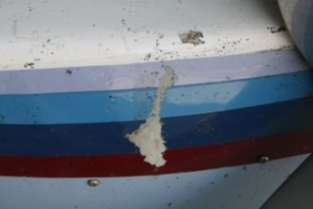

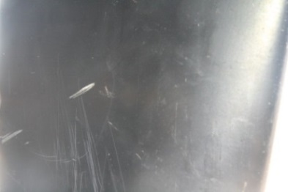

**Figure 10:**

**False Positive UAS Strike in Leesburg, Virginia – *June 22, 2015; N5210D; Cessna 172S***

**Source:** FAA incident report: AWA4515

**Synopsis:** Student pilot flying on a solo cross-country reported hitting a UAS at 3,500 feet. Landed. Came back and found substantial damage to right wing. No visual evidence of bird remains.

**Investigation:** FAA took photos of damaged wing and sent parts in to lab. Part examined and swabs taken at Smithsonian Feather Identification Lab.

**Conclusion:**

* *Airplane collided with a large black vulture*

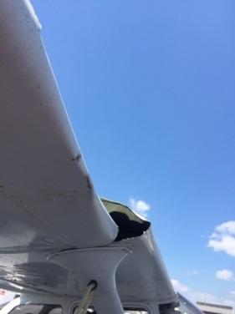 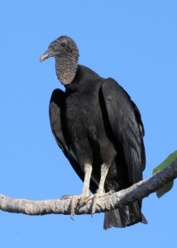

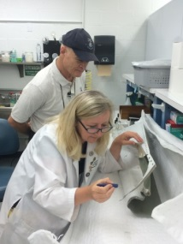 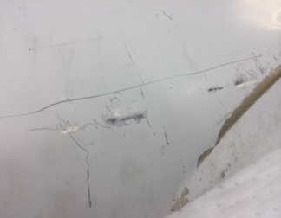

**Figure 11:**

**False Positive UAS Strike in Joliet, Illinois – *August 27, 2015; Piper PA-23 Aztec***

**Source:** NTSB Case no. CEN15IA385

**Synopsis:** Pilot flying at 140 knots and 2,500 feet above the ground. He heard a “pop”. During post-flight inspection, pilot noticed damage to left horizontal stabilizer. No blood found.

**Investigation:**

Swabs of damaged area were taken and sent to the Smithsonian Feather Identification Lab.

**Conclusion:**

* Airplane collided with a dove or pigeon.

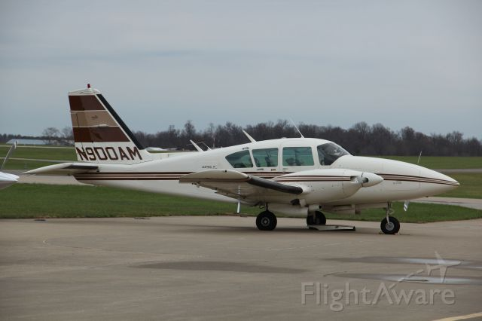

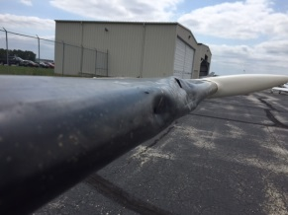 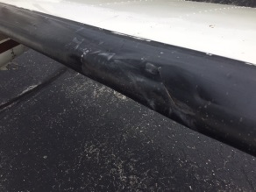

**Figure 12:**

**False Positive UAS Strike in Van Nuys, California – *November 23, 2015; Robinson R22 Helicopter***

**Source:** FAA incident report:

**Synopsis:** Instructional flight at night, at 800 feet and 70 knots, with instructor and student. Left-side bubble windscreen imploded as pilots reported hitting something.

**Investigation:** FAA and NTSB queried recorded radar data track of helicopter, listened to ATC tapes, examined interior of helicopter for bird remains or UAS parts (None found). Took swabs of remaining Plexiglas pieces.

**Conclusion:**

* *Undetermined. No evidence of UAS strike. May have been a bird strike, or structural deficiency with the Plexiglas material or installation.*

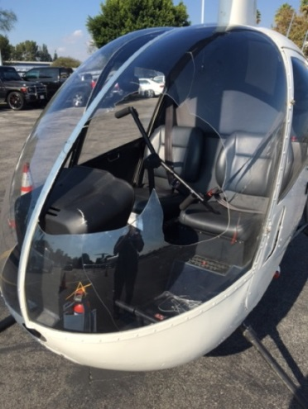 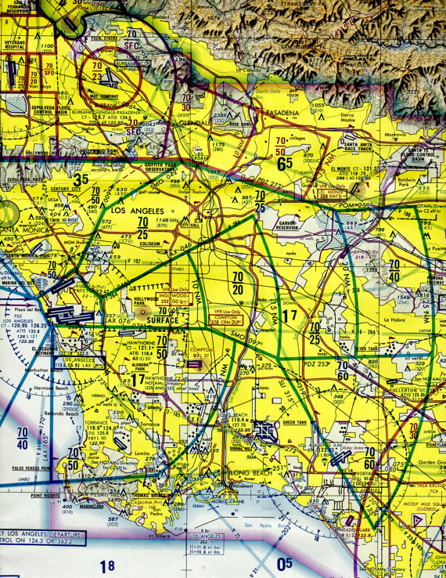

**Area of Reported Collision**

**Van Nuys Airport**

**LAX Airport**

**Figure 13:**

**False Positive UAS Strike in Opa Locka, Florida – *January 4, 2016; Beech Kingair***

**Source:** FAA incident report.

**Synopsis:** On takeoff, pilot heard and felt a loud bang near tail of the airplane. He landed at a nearby airport and noted damage and marks on the tail.

**Investigation:** Swabs taken of the damage. No organic material or bird remnants found. Detailed sweep of departure runway and airport did not yield any evidence of UAS parts.

**Conclusion:**

* *Undetermined*

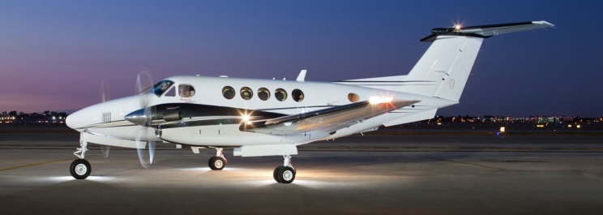

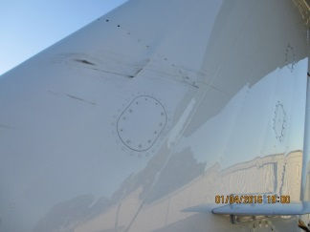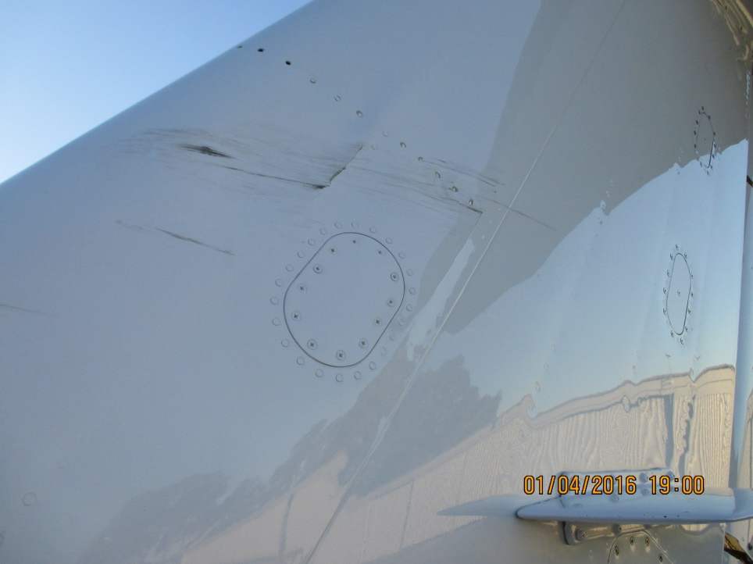

**Figure 14**

**False Positive UAS Strike in London,****England – *April 17, 2016; Airbus A320***

**Source:** News Media (The U.K. Daily Mail)

**Synopsis:** British Airways flight crew reported .

**Investigation:** FAA and NTSB queried pilots …

That location is the ECA R235/29.17 or LVK airport R141/10.75.

**Conclusion:**

* No evidence of a collision. Crew likely saw a plastic bag floating near them.

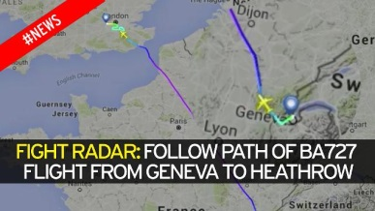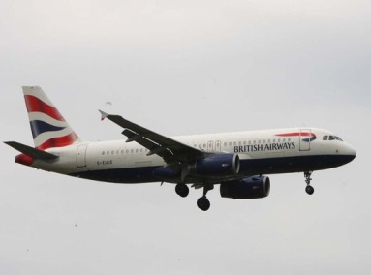

**Conclusion:**

Although there have been no verified collisions between a human-piloted aircraft and a UAS, the close monitoring -- and in some cases, the investigation -- of UAS close encounters is an important strategy that should be utilized to ensure that designed safety measures are effectively being implemented. Likewise, in addition to accident and serious incident investigations, methodical examination of UAS sightings could enhance the community’s understanding of which factors contribute the most significant risks to safety and would support ongoing research and development efforts. The reporting and investigating of UAS accidents and incidents – even when they didn’t really happen – will most certainly “make a difference” in preventing the next (or the first) catastrophic UAS encounter by informing the public, the aviation industry, and safety researchers about actual UAS collision risks.

________________________________________________________________________

**References**:

1. Department of Transportation Office of Inspector General; FAA Lacks a Risk-Based Oversight Process for Civil Unmanned Aircraft Systems. Report No. AV-2017-018. Issued December 1, 2016. Page 1. <https://www.oig.dot.gov/library-item/35367>

2. Federal Aviation Administration Aerospace Forecast: Fiscal Year 2016-2036. March 24, 2016.

<https://www.faa.gov/data_research/aviation/aerospace_forecasts/media/FY2016-36_FAA_Aerospace_Forecast.pdf>,

3. Federal Aviation Administration: Guidance for Effective UAS Safety Risk Analysis. AVP-200. June 1, 2016.

4. Federal Aviation Administration, Integrated Safety Assessment Model: Integrating UAS Operations. September 30, 2016 (Version 2). p. 11.

5. Federal Aviation Administration *Interim Final Rule on Registration and Marking Requirements for Small Unmanned Aircraft.* December 2015.

6. U.S Court of Appeals for the DC Circuit. No. 15-1495, Taylor v. Huerta, Decision data May 19, 2017.

7. 14 Code of Federal Regulations Part 107, Final Rule; *Operation and Certification of Small Unmanned Aircraft Systems.* Federal Aviation Administration.

8. Department of Transportation Office of Inspector General; FAA Lacks a Risk-Based Oversight Process for Civil Unmanned Aircraft Systems. Report No. AV-2017-018. Issued December 1, 2016. Page 1. <https://www.oig.dot.gov/library-item/35367>

9. 14 Code of Federal Regulations Part 107, Final Rule; *Operation and Certification of Small Unmanned Aircraft Systems.* Federal Aviation Administration.

10. *14 Code of Federal Regulations Part 107*, Final Rule; *Operation and Certification of Small Unmanned Aircraft Systems.* Federal Aviation Administration. Paragraph 107.9, Accident Reporting.

11. Federal Aviation Administration Web Site. Part 107 accident reporting form. <https://www.faa.gov/uas/report_accident/>

12. Federal Aviation Administration AUS-410. AUS Data Management electronic status report. July 7, 2017.

13. Federal Register. <https://www.ecfr.gov/cgi-bin/texdx?SID=bc13aaa96b1d2b48777cdae2198a2d7a&mc=true&node=pt49.7.830&rgn=div5>

14. All five of these UAS accident reports can be found on the NTSB’s web site at [www.NTSB.gov](http://www.NTSB.gov)

15. Farrier, Thomas A. *Unmanned Aircraft System Accidents: Learning to Predict the Unpredictable.* ISASI paper presented at the 2013 ISASI Annual Seminar in Vancouver, Canada.

16. U.S. National Transportation Safety Board. *Advisory to Operators of Civil Unmanned Aircraft Systems in the United States*, July 29, 2016.<https://www.ntsb.gov/investigations/process/Documents/NTSB-Advisory-Drones.pdf>

17. FAA Order 8020.11C, *Aircraft Accident and Incident Investigation, Reporting, and Notification*

18. Saunders Hodges, Sabrina. Setting R & D Priorities: Industry Development vs. Regulatory & Operational Responsibility. FAA UAS Symposium, Reston, Virginia. March 27, 2017.

19. FAA Implementation Plan for Integration of Unmanned Aircraft Systems into the National Airspace System. September 15, 2016.

20. General Accountability Office; Safety Risks Associated with Small Unmanned Aircraft Systems. July 2017.

21. Federal Aviation Administration. Law Enforcement Assistance Program Aviation Guide. September 22, 2016.. <https://www.faa.gov/about/office_org/headquarters_offices/ash/ash_programs/investigations/leap/>

22. Department of Transportation Office of Inspector General; FAA Lacks a Risk-Based Oversight Process for Civil Unmanned Aircraft Systems. Report No. AV-2017-018. Issued December 1, 2016. Page 9-10. <https://www.oig.dot.gov/library-item/35367>

23. Federal Aviation Administration: Guidance for Effective UAS Safety Risk Analysis. AVP-200. June 1, 2016.

24. Alliance for System Safety of UAS through Research Excellence. March 24, 2016. [www.assureuas.org](http://www.assureuas.org).

25. Eli Dourado and Samuel Hammond, “Do Consumer Drones Endanger the National Airspace? Evidence from Wildlife Strike Data,” March 14, 2016, Mercatus Center, George Mason University, <http://mercatus.org/publication/do-consumer-drones-endanger-national-airspace-evidence-wildlife-strike-data>.

26. A3 Airborne Collision Severity Abstract. ASSURE Wichita State University. March 30, 2016.

<http://www.assureuas.org/cgi-bin/assure-swish.cgi?query=wichita>

27. Federal Aviation Administration, Integrated Safety Assessment Model: Integrating UAS Operations. September 30, 2016 (Version 2).

28. Federal Aviation Administration, Integrated Safety Assessment Model: Integrating UAS Operations. September 30, 2016 (Version 2).

29. Erin Dooley, “British Airways Flight May Have Been Hit by Plastic Bag: Official,” ABC News, April 22, 2016, <http://abcnews.go.com/International/british-airways-flight-hit-plastic-bag-official/story?id=38600653>

30. FAA 8020-23 Accident/Incident Report Form.

31. NTSB Case no. CEN15IA385; <https://www.ntsb.gov/_layouts/ntsb.aviation/brief.aspx?ev_id=20150827X82014&key=1>